MOSH
Weekly Programme
Monday 11th December to Friday 15th December
Monday 11th | Tuesday 12th | Wednesday 13th | Thursday 14th | Friday 15th
outside/inside ball games  ***  “quiet time”  or homework choices  &  sand pit play | outside/inside  ball games  ***  “quiet time”  or homework choices  &  marble painting  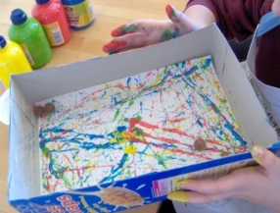 | outside/inside  ball games  ***  “quiet time”  or homework choices  &  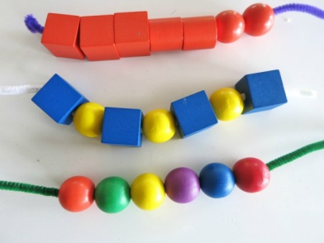  beading | outside/inside ball games  ***  “quiet time”  or homework choices  &  dress ups | outside/inside  ball games  ***  “quiet time”  or homework choices  &  making aeroplanes

