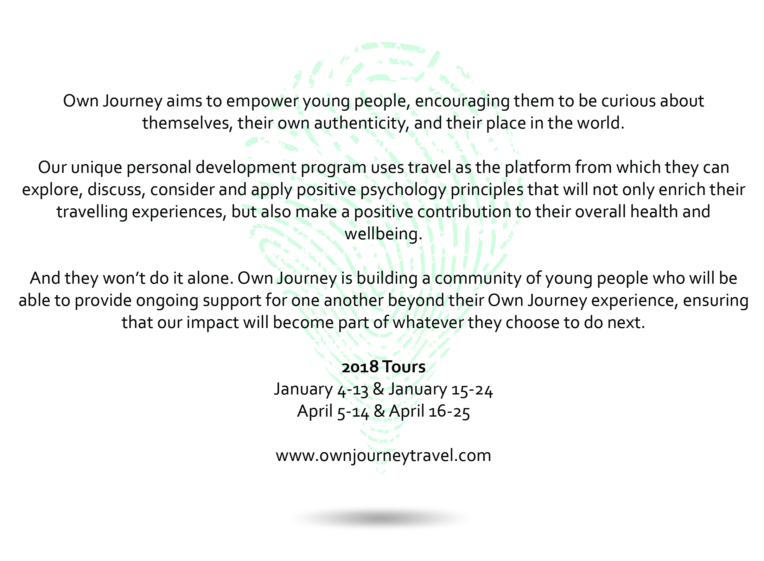
Further information:
Own Journey is a unique experience that will help build school-leavers as a whole person and prepare them for whatever lies ahead. It has been founded by Chyloe Kurdas, a former elite AFL footballer, and a key player in the emergence of women’s football. Her work building the U/18 pathway for elite youth female footballers became a catalyst for the creation of the AFLW competition, creating change in individuals and culture across the country. Having worked in education and then sport, Chyloe has a passion for investing in the holistic development, wellbeing and empowerment of young people, and the power of community.
Own Journey is an incredible opportunity for ongoing personal development and friendship, and one that should be considered by all whether commencing a gap year, or heading straight into tertiary education or work.
For more information, feel free to browse the above website or contact Chyloe at Own Journey:
Phone: 0418 572 902 Email: admin@ownjourneytravel.com

