Alphington Football Club Inc. A0059611S ABN:68 971 145 656
Website: www.alphingtonfc.com A: PO Box 5063 Alphington Vic 3078 E:admin@alphingtonfc.com

Alphington Football Club is a welcoming, community run soccer club based at Alphington Park, Parkview Rd, Alphington. It fields senior teams, junior teams and a development squad (mini roos).
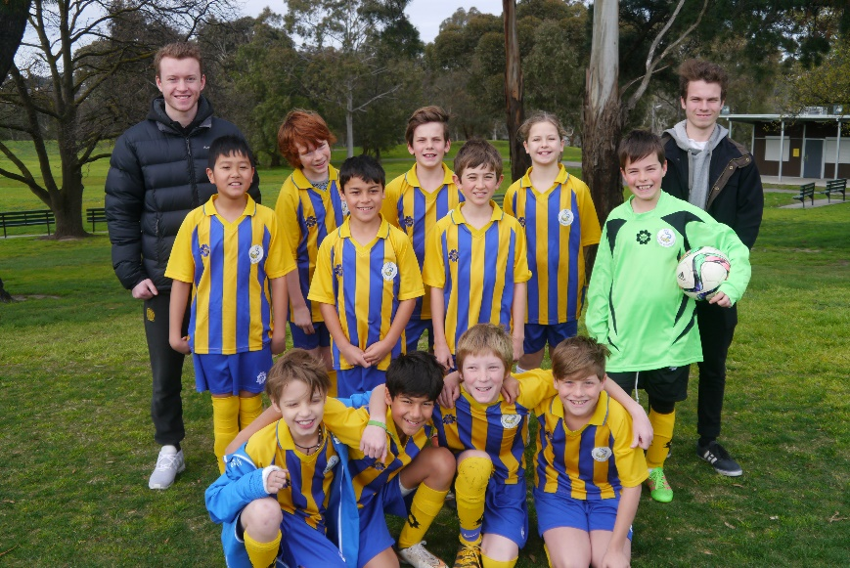
We are currently seeking expressions of interest from anyone, both male or female, who is looking to join a team or our mini roos in 2017.

Expressions of interest should be forwarded to admin@alphingtonfc.com.
Or phone Elaine McPartlin, Interim Club President, on 0438 583 522.

Sponsored by:

