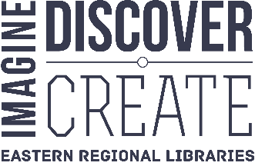
Eastern Regional Libraries
1350 Ferntree Gully Road
Scoresby 3179

Dear Parent/Guardian

Exciting News - Your child can use their school ID card as an Eastern Regional Library card!

We’ve partnered with Eastern Regional Libraries to allow students to access local library resources using their RSC Compass ID card. Activating their card will allow your child access to the following:
- a vast range of research and literacy tools
- almost 50,000 free ebooks
- several premium online resources including Encyclopedia Britannica and Literacy Planet.

Additionally, they can borrow books, DVDs, magazines and video games from 14 libraries.

If you wish to take advantage of this wonderful offer, please follow the instructions overleaf to activate this service.

Participating libraries include: Realm, Croydon, Knox, and Ferntree Gully.

Please be aware that Eastern Regional Libraries is a Local Government Entity that complies with the Privacy and Data Protection Act 2014. If you choose to activate this feature some information about your child will be shared with the library. It is also a requirement that you act as guarantor for your child and agree to the conditions of membership. These can be viewed at www.yourlibrary.com.au

Yours sincerely

Emily Collins and Deb Wilkins
Library Coordinators
Ringwood Secondary College

Activating Library Services

Introduction:
Students with a school ID card that says Compass on the back side are able to use that card to access many library services. This feature must be enabled via the Compass Online Portal for each student.

Requirements:
- A child with a student ID card that displays the word Compass in a blue box on the back side
- A computer with access to the Compass School Portal for your child

Procedure:
- Visit the Compass School Portal via the normal login URL for the student and log in
https://ringwoodsc-vic.compass.education/login.aspx
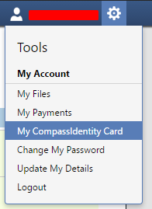
- Click on the cog icon which looks like a gear and takes you to the settings
- Click on My CompassIdentity Card
- Scroll down on the page to the Externally Linked Card Services page and check the box in the row corresponding to your child’s name and the partner service Eastern Regional Library Corporation.
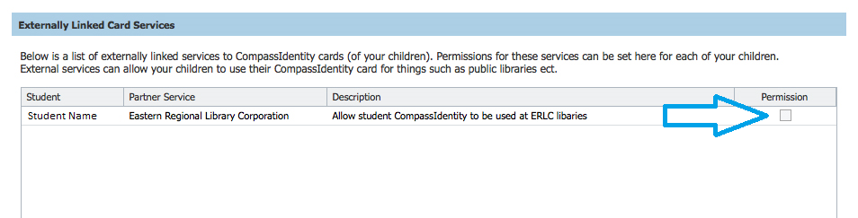
That’s it! The student’s card will now work with most library services including the borrowing of items in branches, downloading 50,000+ ebooks and countless study resources via the library’s website.

Notes:
- Library membership is subject to the membership conditions available at www.yourlibrary.com.au
- Items can be borrowed for three weeks and charges apply to items returned late. Overdue charges are impossible for downloadable items!
- The process above must be repeated each new school year
- When borrowing items from the library, students should use the barcode on the rear of their student card. Additionally, they should use the 10 digit number located on the back of the card when logging into library apps. Some of which require a PIN, this is set to the student’s date of birth formatted DDMMYY. It can be changed online at www.yourlibrary.com.au

