Kids Menu

Chicken nuggets, chips and salad…………………………………………………….. $12

Sausages, chips and salad………………………………………................................. $12

Fish, chips and salad……………………………………………………………………………. $12

Cheeseburger and chips……………………………………………………………………...$12

Ice cream scoop and topping…………………………………………………………….…$3

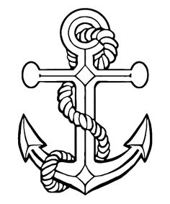

Kids Menu

Chicken nuggets, chips and salad…………………………………………………….. $12

Sausages, chips and salad………………………………………................................. $12

Fish, chips and salad……………………………………………………………………………. $12

Cheeseburger and chips……………………………………………………………………...$12

Ice cream scoop and topping…………………………………………………………….…$3
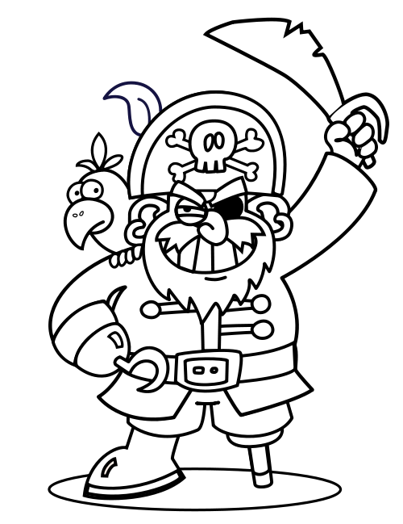

Kids Menu

Chicken nuggets, chips and salad…………………………………………………….. $12

Sausages, chips and salad………………………………………................................. $12

Fish, chips and salad……………………………………………………………………………. $12

Cheeseburger and chips……………………………………………………………………...$12

Ice cream scoop and topping…………………………………………………………….…$3
