NAME:………………………………………………………………………………………………………………………………………………………
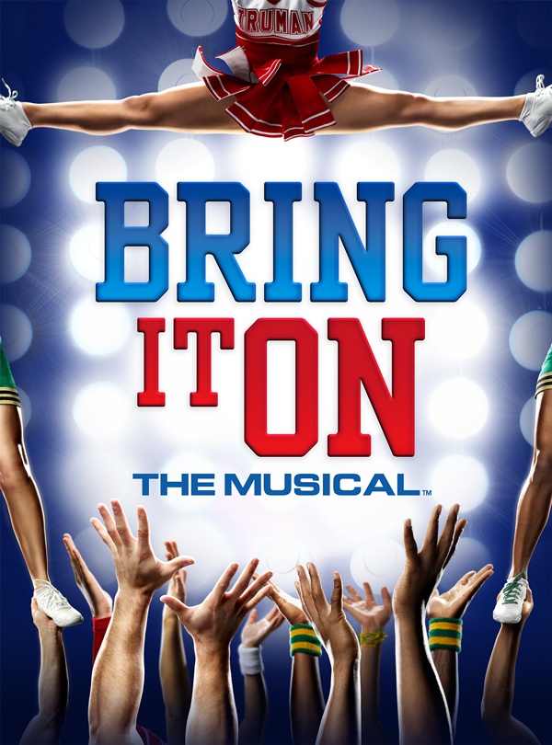

Welcome from the Producer
Congratulations on being involved in this year’s production of BRING IT ON! I look forward to working with you on our journey. Sometimes it may feel like hard work and you may not feel like attending rehearsal, but remember, we, and especially your choreographers, are counting on you! Sometimes it will feel like it is never going to come together but it always does- that’s the magic of theatre! You will be rewarded for all your hard work and remember these things:
You only get out of something what you put into it.
There is no such thing as a small part, only a small actor. Enjoy every minute of your time on stage!
Important Dates Reminders
PERFORMANCE DATES: Wednesday 8th, Thursday 9th, Friday 10th August (Cast 1) &
Wednesday 15th, Thursday 16th & Friday 17th of August. (Cast 2)
(Week 4 & 5 of Term 3)
VENUE: MELBOURNE GIRLS’ COLLEGE, 7.30PM.
Sunday, 22nd July- Rehearsal- Cast/Leads only
Sunday 29th July and Sunday 5th August (TBC)
Bump In: Monday 6th August. This is when all the equipment arrives. Crew only.
Tech rehearsal: Tuesday 7th August. This is when all the lights and audio is tested. Crew only required. Cast on call.
Dress Rehearsal: Tuesday 7th August afterschool, 2.30-4.30pm approx. All required
Full Dress Rehearsal: Wednesday 8th August, Periods 1-3. All required
(Please note early dismissal to allow time to freshen up before opening night!)
Performance Evenings
Cast, Crew & Musicians required @ 6pm for makeup/set up/tune up
Chorus required @ 6.30pm.
Compulsory preshow meeting @ 6.30pm in the Auditorium for everybody
Doors open: 7.15pm
Show Starts 7.30pm
Interval-8.40 approx
Show Ends 9.45 approx.
Please make sure you have a lift home- organize a car pool or a buddy to travel with. Don’t travel alone
Chookas!
Anne Corry
Introduction of Production Team
Producer & Co-Director: Anne Corry
Co-Director: Lindy Mumme
Student Choreographers: TBC
Musical Director: Andy Clarke
Vocal Coach: Ellyce Calder
Technical Director: Trevor Howlett.
Stage Manager: Florence Honeybun
Set Design & Construction: Students
Backstage Crew: Students, led by Mae James
Audio: Students
Lights: Students
Props: Students
Video: Students
Front of House (F.O.H) Student Executive
(NB-FOH is out of bounds to students during the show)

MGC’s Past Musical Productions
2016 The Wizard of Oz
2014 Back to the 80’s
2012 Grease
2010 Annie
2008 The Sound of Music
2006 Back to the 80’s
2004 Oliver
2002 The Wizard of Oz
2000 Annie
1998 Bye Bye Birdie

My Parts in the Wizard of Oz!
Please highlight which scenes you are in.
Bring it On-Act One
Scene/Set | Musical Number | People Required
1 | What I Was Born to Do:  Truman Chorus | Campbell, Skylar, Kylar, Bridget, Steven, Goth girls, Trumann Squad
2. | Happy Kitties-Campbell & Steven | Steven, Campbell, Skylar, Kylar, Bridget, Eva
3  Cheer Camp | Tryouts-Skylar  Perfect Moment -Campbell | Trumann Squad & Truman leads
4  Campbell’s Bedroom | Perfect Moment (Reprise) | Campbell, Eva, Skylar, Kylar, Steven
Scene 5  Jackson High School | Do Your Own Thing  The Day Goes By: Jackson Crew | Campbell, Bridget, Randall, Cameron, Twig, Danielle, Nautica & La Cienga  Jackson Crew
Scene 6  Jackson High | We Ain’t No Cheerleaders:  Specialist Singers | Campbell, Bridget, Randall, Cameron, Twig, Danielle, Nautica & La Cienga
Scene 7 | Phone Calls/To the Pagoda | Eva, Skylar, Kylar, Steven
Scene 8  Burger King |  | Campbell, Danielle, Bridget, Rich girls
Scene 9  Jackson Hich | Friday Night:  Jackson Chorus | Cameron, Twig, Randall, Crew Girls
Scene 10  Campbell’s/Eva’s Bedroom | Something isn’t Right Here-Campbell  Bring it On- Specialist Dancers | Skylar, Campbell, Kylar, Eva, Steven, Bridget

Act 2
Scene/Set | Musical Number | People Required
1  Jackson High | It’s All Happening:  Jackson Chorus | Campbell, Danielle, Nautica, La C, Randall, Twig, Bridget, Cameron
2  Jackson Gym/Trumann Gym | Better-Skylar  Douchenozzle in Hell-Eva & Backups | Eva, Randall, Campbell, Danille, Bridget, La C & Nautica
3  Qualifying |  | Eva, Skylar, Kylar, Campbell, Steven, Danielle, Nautica, La C
4  Jackson Hallway | It Ain’t No Thing-  Specialist Singers | Twig, Bridget, Nautica & La C
5  Hallway |  | Campbell, Bridget, Randall, Daniell, La C & Nautica
6  Picnic | Enjoy the Trip-Duet | Campbell & Randall
7  Eva’s Bedroom | Killer Instinct-Eva & Backups | Eva, Skylar, Kylar
8  Jackson | We’re Not Done-Duet | Bridget & Twig, Nautica & La C, Campbell & Danielle
9  Nationals | Legendary:  Truman Chorus | Trumann Squad
10  Holding Area | Eva’s Rant  Cross the Line:  Specialist Dancers  I Got You:  Leads | Eva, Skylar, Kylar, Campbell, Danielle, Nautica, La C, Bridget, Twig, Randall, Steven, Campbell

Bring It On Rehearsal Schedule Term 2
WEEK  1 | TUES  AFTERSCHOOL  2.30-3.30-Chorus  3.30-4pm-Cast | WED  LUNCH-Band | THUR  Lunch-  Soloists with Nick | FRI  LUNCH
 |  |  | Afterschool
 | Truman Chorus-Intro |  | Cast
 | Jackson Chorus-Intro |  | Specialist Dancers-Bring It On
2 | Truman Chorus-WIWBTOD | ANZAC DAY | OPEN DAY | Soloists
 | Jackson Chorus- DYOT |  | Cast
 |  |  | Specialist Dancers- Bring It On
 | Week 3-Parent Interviews |  | Cast
 |  |  | Specialist Dancers- Bring It On
4 | Truman Chorus- WIWBTOD | Soloists | Soloists- with Nick | Soloists
 | Jackson Chorus- DYOT |  | Cast
 |  |  | Specialist Dancers- Bring It On
5 | Truman Chorus- WIWBTOD | Soloists | Soloists- with Nick | Soloists
 | Jackson Chorus-FNJ |  | Cast
 |  |  | Specialist Dancers-Cross the Line
6 | Truman Chorus-Legendary | Soloists | Soloists- with Nick | Soloists  (Dance Night)
 | Jackson Chorus- FNJ |  | Cast  (Dance Night)
7 | Truman Chorus- Legendary | Soloists | Soloists- with Nick | Soloists
 | Jackson Chorus- FNJ |  | Cast
 |  |  | Specialist Dancers- Cross the Line
8 | Truman Chorus- Legendary | Soloists | Soloists- with Nick | Soloists
 | Jackson Chorus- FNJ |  | Cast
 |  |  | Specialist Dancers- Cross the Line
9 | Truman Chorus- Legendary | GAT | Soloists- with Nick | REPORT WRITING DAY
 | Jackson Chorus-IAH |  | Cast
 |  |  | Specialist Dancers- Cross the Line
10 | Truman Chorus-Cheer Camp | Soloists | Soloists- with Nick | Soloists
 | Jackson Chorus- IAH |  | Cast
 |  |  | Specialist Dancers- Cross the Line
11 | Truman Chorus-Cheer Camp | Soloists | Soloists- with Nick | Soloists
 | Jackson Chorus- IAH  (Vocal Showcase) |  | Cast
 |  |  | Specialist Dancers- Cross the Line

Tuesdays- Truman and Jackson Chorus required 2.30-3.30pm, Cast from 2.30-4pm
Thursday- Specialist Dancers required from 3.30-4.30pm, Cast from 3.30-4.30pm
Attendance at rehearsals is compulsory. If you are unable to attend a rehearsal due to extreme circumstances, please e-mail Ms Corry beforehand. 3 missed consecutive rehearsals without any communication will result in you being dropped from the show.

Bring it On Rehearsal Schedule-Term 3
Week | Monday | Tuesday | Wednesday | Thursday | Friday
1  16th-20th July |  | Act 1- Revision |  | Act 2- Revision
2  ^{23th}-27nd July |  | Run through Act 1 |  | Run through Act 2
3  ^{30th July} -3rd August |  | Run through with Band of Chorus Musical Numbers |  | Cast- Trouble Shooting

Production Week 4- Cast 1
Week | Monday  6th August | Tuesday  7th August | Wednesday  8th August | Thursday  9th August | Friday  10th August
4  6th -10th August | Bump In | Full Dress Rehearsal  2.30-5pm approx.  Everyone!  (Cast 1) | Full Dress Rehearsal Period 1-3.  Everyone!  Early Dismissal | Middle School Sleep in | Middle School Sleep in
 |  |  | Opening Night-Cast 1 | Evening Performance # 2- Cast 1 | Evening Performance # 3-Cast 1 & Presentations

Production Week 4-Cast 2
Week | Monday  13th August | Tuesday  14th August | Wednesday  15th August | Thursday  16th August | Friday  17th August
5  13th -17th August |  | Full Dress Rehearsal 2.30-4.30 approx  Everyone!  (Cast 2) |  | Middle School Sleep in | Middle School Sleep in
 |  |  | Opening Night- Cast 2 | Evening Performance # 2- cast 2 | Final Performance Cast 2 & Presentations

Costumes & Makeup
Unless directed otherwise, you will be responsible for organizing your own costume and make up. You will be given a detailed brief and time to organise this.
Ticket Sales
Tickets for the show will go on sale at the beginning of Term 3 using Trybooking on our school website.
There are only 200 seats available each night so don’t miss out! Make sure you organize your family and friends well before tickets go on sale.
Production Week
Staying back at school? Afterschool supervision is provided for Middleschool Students. This is a good opportunity to have some quiet time, catch up on homework, or watch a DVD. Students do not have permission to leave the school grounds.
Meals
Meals are available from the Café for $10 which includes a meal, drink and snack. Alternatively, BYO dinner and heat it up in the microwave.
What to bring on the night
Named costume, water bottle, nibbles (not lollies) and makeup. Also bring a quiet activity such as a book or deck of cards for when you are not on stage.
What not to bring- valuables. If you need to bring your phone/wallet, make sure you hand it to your supervising teacher for safe keeping.
Performance Night Procedure
Compulsory meeting in Auditorium at 6.30pm.
From there, proceed to your allocated dressing room area.
Sign in and give any valuables to your supervising teacher
Showtime!
Clean up dressing room area and sign out.
Sleep In!
Middle school students have permission to sleep in on the Thursday and Friday mornings. You must be at school in time for Period 2.
Souvenirs
You are welcome to buy a souvenir t-shirt.
All students will receive a complimentary souvenir program.

Bring it on!!

