LEAVE YOUR MARK !
From this -:
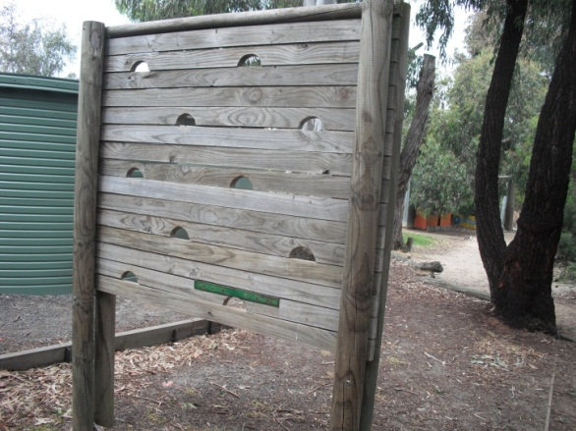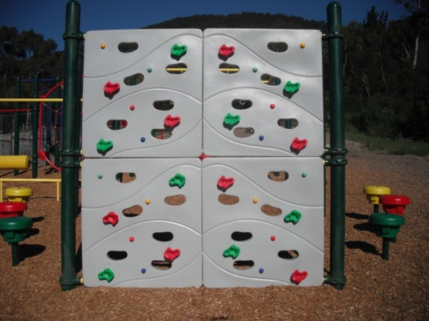
To this -:

For a small donation, you can contribute to the SSPS Community Fitness Track and have your name inscribed for a lifetime !

The kids at SSPS would love to upgrade the 10 fitness stations currently around our fitness track.
We have come up with an idea to give our year 6 families the opportunity of ‘leaving their mark’ on the school, by having their names inscribed on a new station for a small contribution.
Of course it’s not only for year 6 families, anyone can be involved, including family, friends, local businesses.
Please complete the reply slip if you would be interested in ‘Leaving your mark’.
------------------------------------------------------------------------------------------------------------
Leaving your Mark !
Our family would be interested in contributing to the purchase of a new fitness station for our fitness track and leaving our mark, by having our name inscribed onto a plaque attached to the equipment.

Family Name_________________________________

Level of Donation (circle)

Gold - $500 Silver - $250 Bronze - $100

