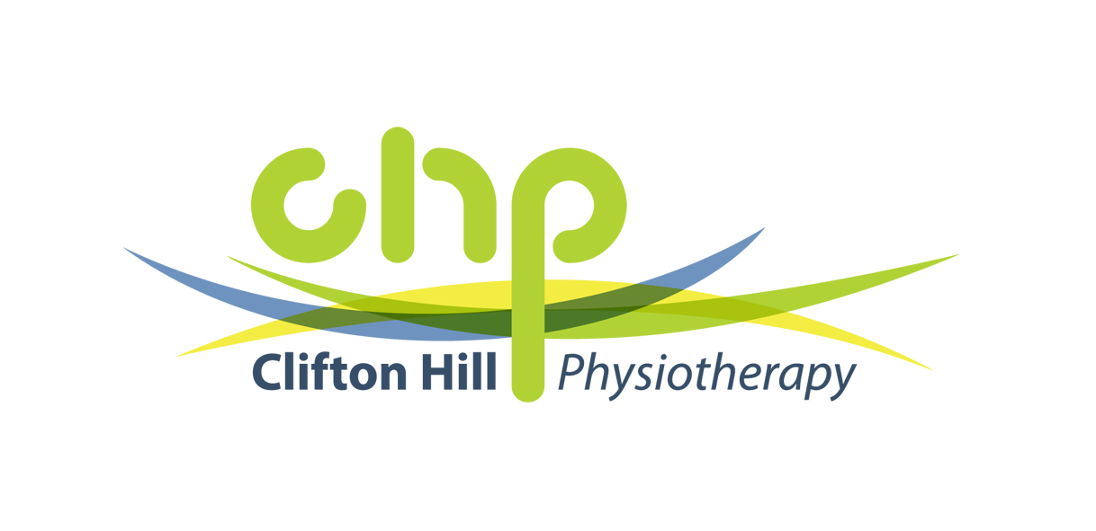
Is your child backpack savvy?
We often see school kids at this time of year with pain and postural issues due to incorrect use of backpacks. We all see a vast array of backpack use mostly hanging on one side, rather than on backs. It seems the word back-pack has lost its true meaning!
Although this digital era has reduced the weight of backpacks, incorrect use of a bag still puts unnecessary strain on backs and necks, resulting in pain and poor posture.
The Australian Physiotherapy Association recommends that children’s backpacks should weigh no more than 10% of the child’s bodyweight. This means that for a 13 year old girl weighing 45kg, the maximum weight her backpack should be is 4.5kg.
Obviously, back pain can result from a number of other factors, such as extended periods of inactivity, poor sitting posture and other conditions. A heavy bag can result in unnecessary and unaccustomed weight being placed on a developing child’s spine.
The following recommendations can reduce back pack induced issues:
- Ensure the bag does not sit lower than 10cm below your child’s waistline.
- Make sure your child’s bag weighs no more than 10% of his/her bodyweight.
- The backpack should be as close as possible to your child’s back, rather than near their bottom.
- Children should try to stand straight whilst carrying a bag, rather than leaning forwards to backwards.
- Always use both straps and avoid carrying a bag on one shoulder.
- Avoid unnecessarily carrying heavy books to/from school.
- If catching public transport, children and teenagers should place their bag on the floor.
Take a few minutes to check your child’s back-pack now and have a healthy 2016 school year.
Dóra Kónya
Paediatric Physiotherapist
B (Physio), M(Physio)
Member of the Australian Physiotherapy Association National Paediatric Group

Useful websites:
Australian Physiotherapy Association
https://www.physiotherapy.asn.au/APAWCM/The_APA/news/2014/December/Don%E2%80%99t_break_the_back_going_back_to_school.aspx
Better Health Channel
http://www3.betterhealth.vic.gov.au/bhcv2/bhcpdf.nsf/ByPDF/Back_pain_schoolbags/$File/Back_pain_schoolbags.pdf
Choice
https://www.choice.com.au/babies-and-kids/education-and-childcare/education/buying-guides/school-backpacks
Spartan – School Supply Specialist (Endorsed by the Australian Physiotherapy Association).
http://www.spartanss.com.au/physiopak-videos/w1/i1168276/

