Central Australia Immersion and Community Service Project.
Year 9 & 10 Camp Opportunity
August 15th – Aug 22nd 2016

This tour was introduced to our current Year 10 students at the end of 2015. There are still places available and we would like to open the invitation to our Year 9 students. We do apologise for the short time frame in regards to payment. A total of 30 students may attend the camp. If we receive more than 30 deposits by Friday, students and families will be informed of the selection process.

Students attending the camp will receive permission forms and further details later this term.

NT Cultural Immersion Program payment plan:
Initial Deposit - $100: Due: Friday 26th February
1st instalment - $400: Due: Friday 18th March, 2016
2nd instalment - $1100: Due: Friday 15th April, 2016
3rd instalment - ~$1000 (TBC): Due: Friday 17th June, 2016

Estimated Tour price: $ 2600 – depending on final cost of flights and student numbers. Any surplus money will be returned.

Tour cost inclusions:
- One way economy airfares flying Virgin (Melbourne – Ayers Rock)
- One way economy airfares flying Qantas (Alice Springs – Melbourne)
- 1 x night Permanent Camp Yulara
- 4 x nights Camping at Lilla
- 2 x night camping at Earth Sanctuary Alice Springs
- Swags (and dome tents)
- Fully accredited guide (including Wilderness first Aid + Working with children check)
- All ground transport as per itinerary
- Sightseeing and activities as per itinerary
- Meals as per itinerary
- Entry fees:
- Alice Springs Desert Park
- Royal Flying Doctor Base

Additional items also included:
- Domestic Travel Insurance
- Staffing costs
- Contingency costs – (i.e. changes in flight prices, surplus monies will be returned).

Itinerary
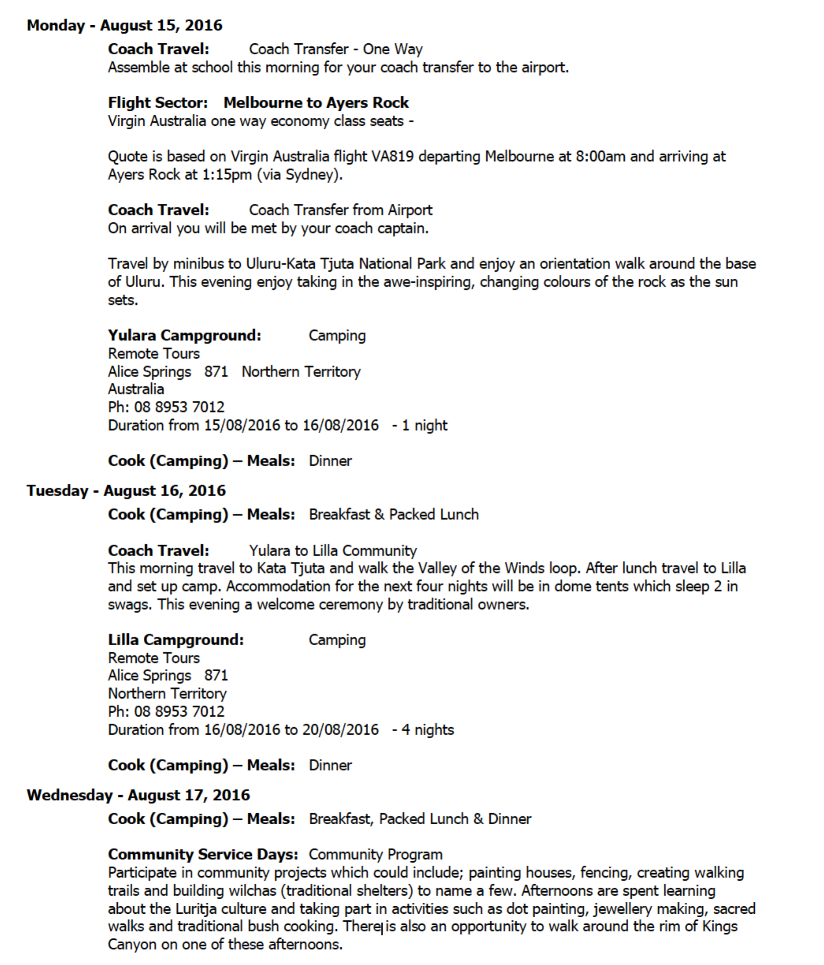

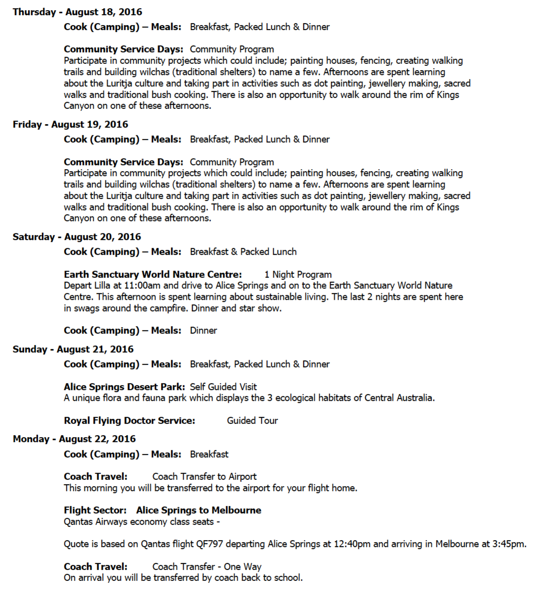

YOUR RESPONSIBILITY: TO PROVIDE A LILO, SLEEPING BAG, TOWEL, TEA TOWEL, CUTLERY AND CROCKERY

Information shared from www.lillafoundation.org.au
Lilla Foundation supports remote, Indigenous communities primarily in the Lilla Community and Watarrka region in the Northern Territory Australia. The aim of the Lilla Foundation is to relieve poverty, sickness and helplessness by providing educational programs to Indigenous Australians. Lilla Foundation promotes life skills, independence and a sense of community in an attempt to establish long term social welfare.

Projects

Lilla Foundation has many ongoing projects to help support the remote communities at Lilla and in the Watarrka region. Foundation founder Reg Ramsden actively maintains most projects in the local area with the assistance of many education groups and other philanthropic groups.

Some of our current projects are:
- Maintain and develop market gardens
- Refurbishment of community housing and upgrading of existing infrastructure
- Work with local service providers to facilitate installation of essential household items such as air conditioners, solar hot water systems etc
- Establish remote education campus for interstate student exchange program
- Alleviate food issues and establish delivery program
- Support and develop local indigenous enterprises
- Develop cultural exchange/interaction program between interstate children and local school

Past Accomplishments

Below are some of the past accomplishments completed with the help of various volunteers from schools and visitors from all over Australia:
- Establish and maintain gardens at Lilla and Wanmarra
- Build pathways and access around Lilla
- Build community tables
- Renovate and re-open local school
- Establish food van for local school children
- Supply and install shade structures for local school
- Build and establish basic irrigation
- Donation of household goods through Miss World Australia fundraising events
- Provide funds for ongoing maintenance and repairs of completed projects and basic utilities
Work with other organisation who support the Foundation’s goals – notable organisations: Gadens Lawyers, Have a Ball Foundation, Alpitye Art Studios,

