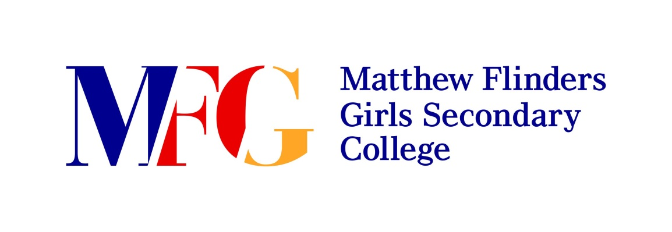

Expression of Interest Form

Mauritius and Reunion Island Trip
March/April 2017

Name: French Teacher:

Form: Parent’s/Guardian’s signature:

