MOSH
Weekly Programme
Monday 18th December to Friday 22nd December
Monday 18th | Tuesday 19th | Wednesday 20th | Thursday 21st | Friday 22nd
outside/inside ball games  ***  “quiet time”  or homework choices  &  wii | outside/inside  ball games  ***  “quiet time”  or homework choices  &  board games  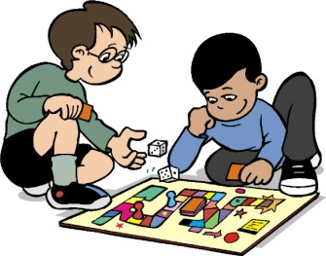 | outside/inside  ball games  ***  “quiet time”  or homework choices  &  make up  &  funky hair | outside/inside ball games  ***  “quiet time”  or homework choices  &  puppets | outside/inside  ball games  ***  “quiet time”  or homework choices  &  Christmas crafts

