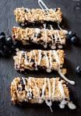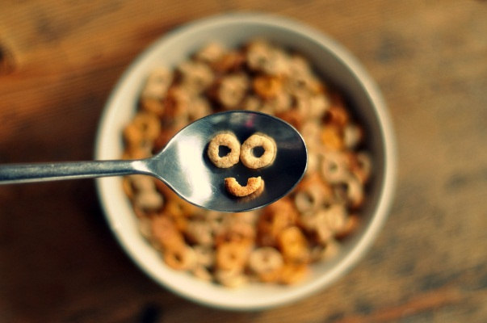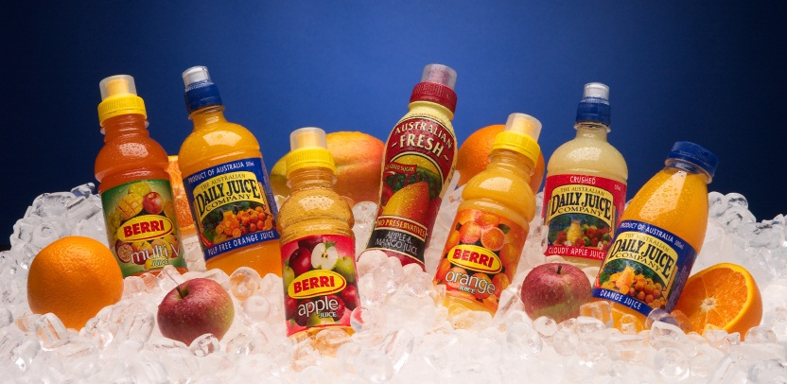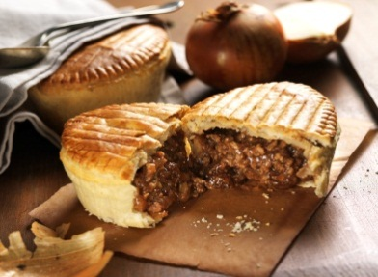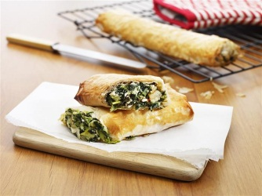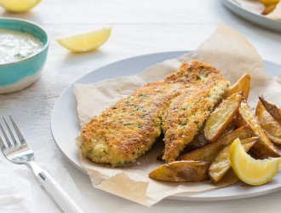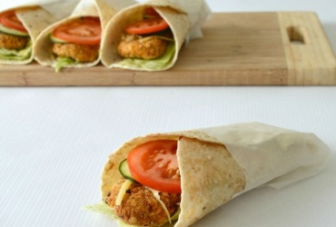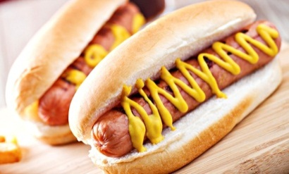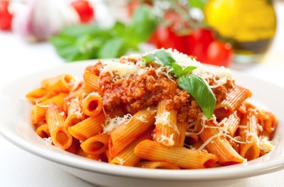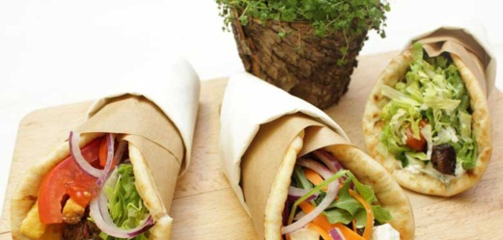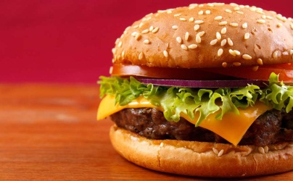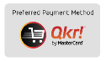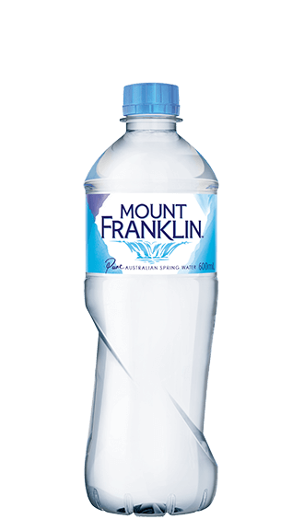

**Cereal Bowls**

With Low Fat Milk

**Free**

**Yoghurt Cups $3.00**

**Wholemeal Toasties**

With Cheese **$2.50**

Cheese & Tomato **$3.00**

Ham & Cheese **$3.50**

**THE CAFE SPECIAL!**

**Egg & Bacon Roll**  **$4.00**

**Gluten Free**

**Buns, Pasta, Pitas,**

**Rolls & Bread**

**Available**

Specially

prepared by

Refresh

food services

BREAKFAST

**WED & FRI**

**8AM-8.45AM**

**Pasta Bolognese**

**$5.00**

**Spinach & Cheese Roll**

**$4.50**

MONDAYS TUESDAYS WEDNESDAYS THURSDAYS FRIDAYS EVERYDAY

**Napoli & Cheese pasta**

**$4.50**

**100% Beef Pie**

**$4.50**

**Mushroom & Beef Pie**

**$4.50**

**Sausage Roll**

**$3.00**

**Baked Chicken Nuggets**

**1 for 50c**

**10 for $4.00**

**Pizza Subs**

**$2.50**

**Hash Browns**

**$1.50**

**Toasted Ham & Cheese Focaccia $3.50**

**Toasted Ham, Cheese & Tomato Focaccia $4.00**

**Assorted Sandwiches**

**From $3.00 - $5.50**

**Salads $4.50**

**Greek**

**Fruit**

**Garden**

**Pasta**

**Juices**

Apple, Orange, Apple & Blackcurrant or Apple, Mango & Banana.

**$2.50**

**Water 600ml $2.00**

**Nippy’s Flavoured Milk**

Chocolate, Honeycomb, Vanilla, Strawberry or Banana

**$3.00**

**Frozen Juice Cups**

Orange, Apple or Apple & Blackcurrant **$1.30**

**Iced Cupcake**

**$2.00**

**Chocolate Ring Donut**

**$2.00**

**Jam Donut**

**$2.50**

**Strawberry Yoghurt**

**$3.00**

**Muesli Bar**

**$1.00**

TREATS

COLD/FROZEN ITEMS

**Beef & Cheese Burger**

with Lettuce, Tomato & Sauce

**$5.00**

**Chicken Schnitzel Burger**

with Lettuce, Cheese & Mayo

**$5.00**

**Lamb Souvlaki**

with Lettuce, Tomato, Tzatziki & Chips in Pita **$6.00**

**Chicken Souvlaki**

with Lettuce, Tomato, Tzatziki & Chips in pita **$6.00** **$6.00**

**Oven Baked Fish Fillet**

with Hand Cut Wedges & Lemon **$5.50**

**Sweet Chilli Chicken Tender Wrap**

**$4.50**

**Grilled Beef Hot Dog**

in a Roll

**$3.50**

**Hot Dog**

in a Roll

**$3.50**

*Download

**SAVE TIME**  
**PRE-ORDER**

**ONLINE**

by 9.30AM with

**QKR** app*

***SPECIAL***

**Meal Deals**

Buy a Daily Special

Meal and add $1

For Spring Water

* NO DEEP FRIED FOOD
* LEAN BEEF, CHICKEN & LAMB
* ONLY LOW FAT DAIRY USED
* NO ADDED PRESERVATIVES
* NO WHITE BREAD
* WHOLEMEAL & MULTIGRAIN

ALL MEALS **FREE** OF **NUTS, SEEDS** & **NO MSG**

**CARWATHA COLLEGE P-12** Summer Menu