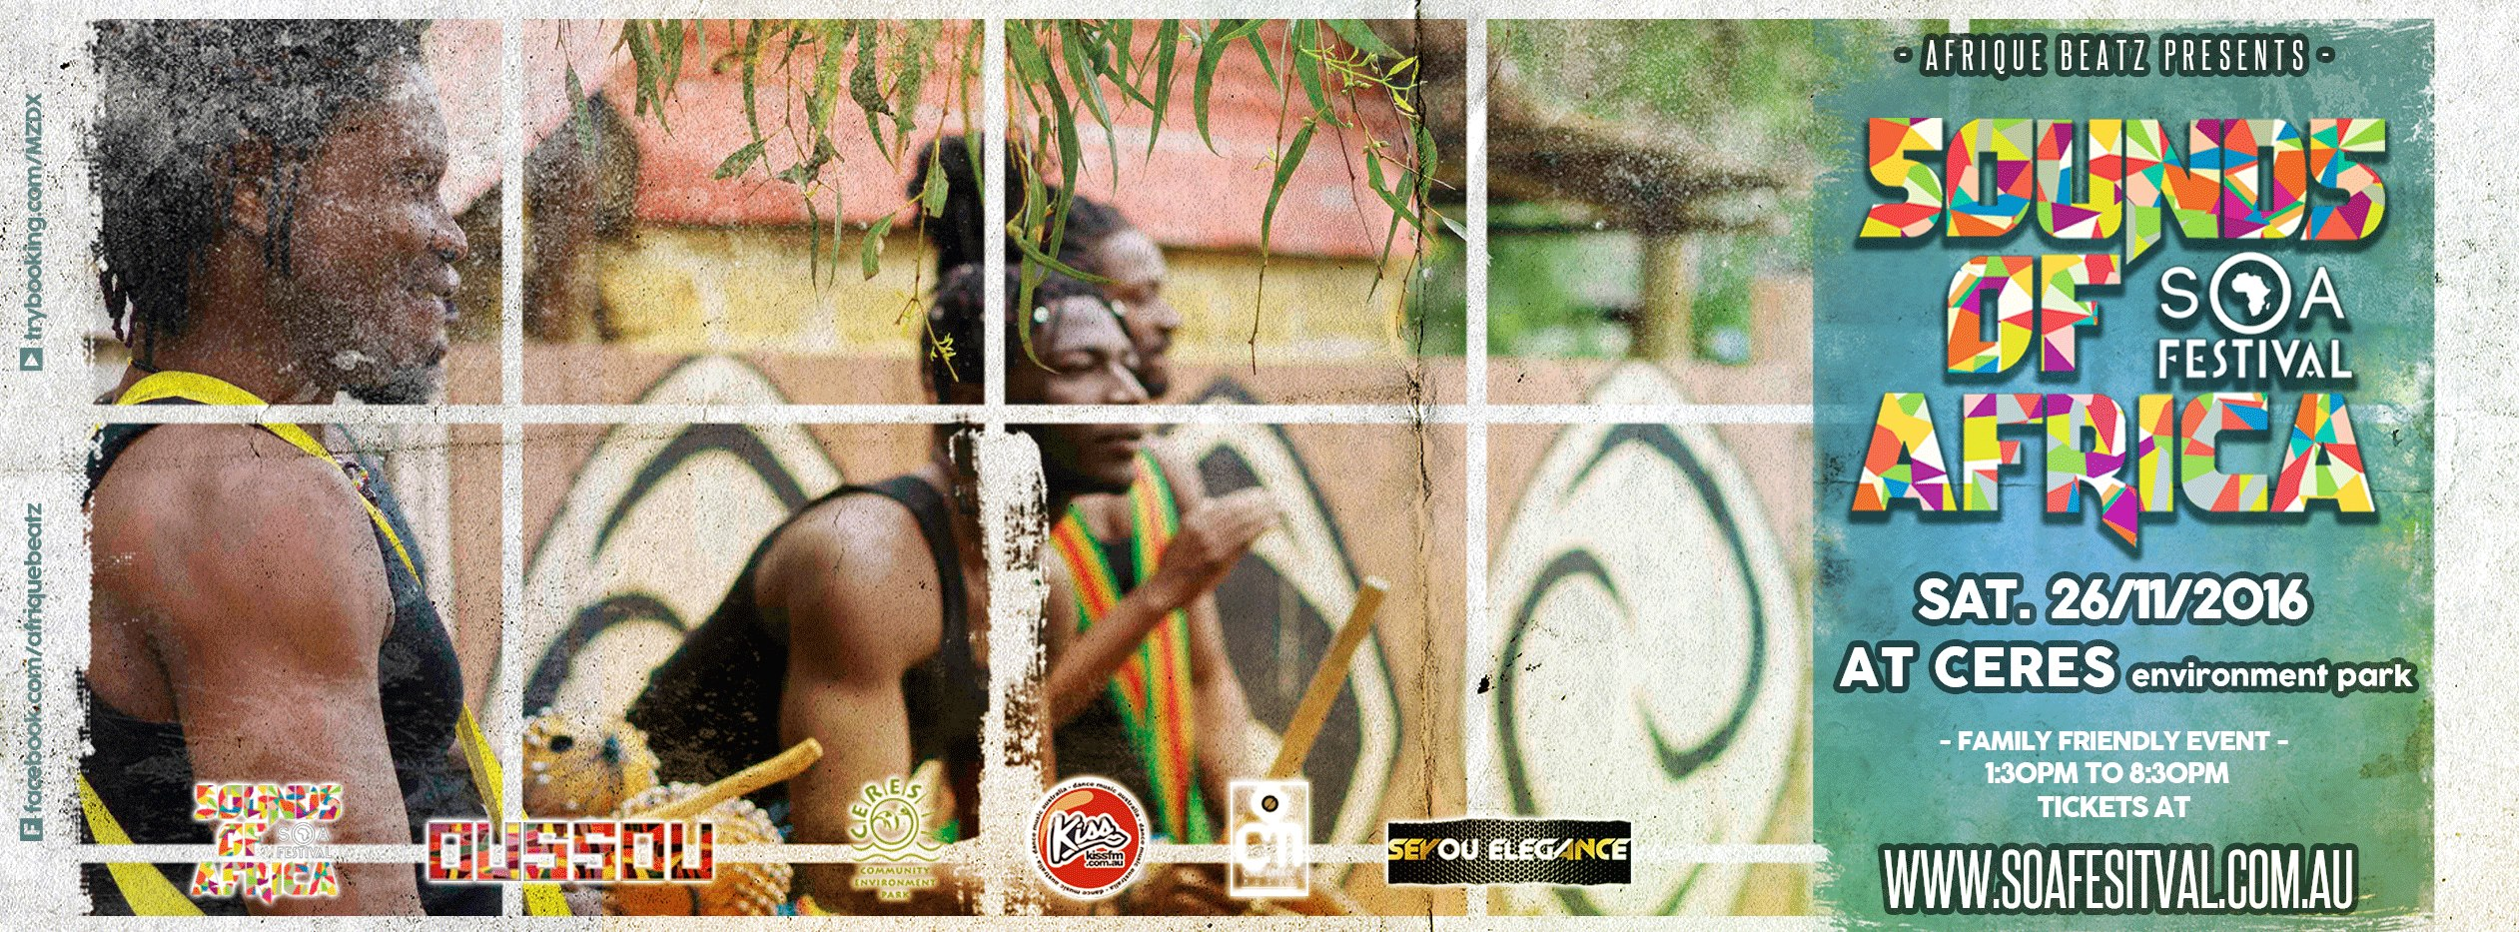

Media Release
‘Sounds of Africa Festival’, is an interactive, family, community festival, whereby, for the very first time, there will be a combination of quality African Artists, including: Music Artists; DJ’s; African Dance; West African Rhythmic Drumming; Performance; & Children’s Workshops- integrated with African business partners supplying their cultural food/drink/ Arts & Crafts. The Festival is a ‘Central Hub’ for the combination of African Culture and Music combined into one Festival.

Professional performing artists have been selected from those living in Melbourne, with many having Australian-wide following and recognition, performing regularly throughout top venues in Australia.

A truly unique event, with artists/musicians/ performers/ and stallholders, all coming together from many different African Countries, such as Cameroon; Ghana; Zimbabwe, Liberia, Mauritius, Sierra Leone, Senegal, Gambia, Congo, Uganda, Guinea, South Africa, and many more to be announced.

Top performing Artists include:

- African Star Dance & Drumming Company- Dance & Drumming performance from Ghana, West Africa.
- Senegambian Jazz Band
• Mohamed Kamara & Jarabi Band- Contemporary & Traditional Music from Guinea, West Africa.
- Mg Kalongi- Afro Reggae Music.
- Flybz- Rapper
- Threenity
- Lawd Bol & T-Green
- Francois- Lyricist
- Afroiginal- Sth African DJ with Didgeridoo player.
- Jungle City Dancehall group
- ‘Afro Vision’
- GGG-Hip Hop Performance
• S K Simeon
- DJ Charly Templar
- DJ Chris NG

FREE –
- Children’s African Drumming Workshop, through ‘African Star Dance & Drumming Company’.
- African Mask Making
- African Story Telling
- African Rock Painting
- Mini Gardens & Terrariums
- African Necklaces

African Arts: Kili Tinga Arts/ Zahara Design African Clothing.
Food Stalls: Coffee/Chillbro Ice-Cream/Sugar Cane Natural Drinks/African BBQ & many more.

This is going to be an amazing, interactive, vibrant, colourful, African event, hosted in Melbourne’s iconic community environment park, ‘Ceres’- in East Brunswick.
The venue is an award winning, not-for-profit, sustainability centre located on 4.5 hectares on the Merri Creek in East Brunswick, Melbourne.
The Festival will be located at the ‘Village Green Stage’.

Details:
Venue: ‘Ceres’- Community Environment Park
‘The Village Green Stage’ & ‘Pavilion’ Areas.
Cnr. Stewart and Robert’s Streets, Brunswick East. Melbourne. Victoria.
Time: 1.30pm –8.30pm
Cost: $20.00 per Adult- 18yrs above.
$10.00 for Children between 12-17rs.
*FREE for children under 12yo
*60.00 Family Pass: 2 Adults & up to 3 Children 12-17yrs.

Avoid disappointment: Limited Tickets sold online only.
Ticketing available through:
http://trybooking.com/MZDX

Further information Contact Details:
The African Beatz Team
Email: afriquebeatz@gmail.com
Facebook: @afriquebeatz

